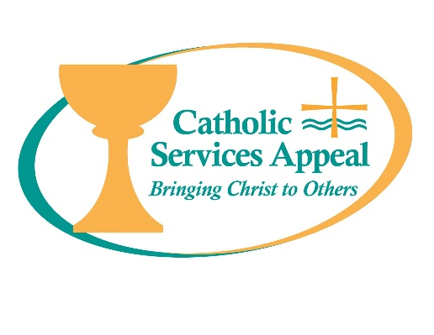

2018 Catholic Services Appeal
Anonymous Donor Matching Challenges

Parishes may find the following blurbs helpful in promoting giving to the 2018 Catholic Services Appeal. Donations that meet either of the two matching challenge criteria below may qualify for double the impact through the great generosity of an anonymous donor to the Archdiocese.

Matching Challenge 1

An anonymous donor to the Archdiocese has generously pledged a $50,000.00 challenge to inspire new gifts from donors unable to participate in last year’s Catholic Services Appeal. This means donations to this year’s Appeal may be doubled when received from households that did not make a gift last year! Please consider making a gift to support the ministries and services of the Catholic Services Appeal.

Matching Challenge 2

An anonymous donor to the Archdiocese has generously pledged a $50,000.00 challenge to inspire new membership in the 2018 Catholic Services Appeal “Salt and Light Giving Society.” For donors able to increase their gift to this year’s Appeal to $500.00 or more, the amount of your increase over last year may be doubled! Please consider making a gift to support the ministries and services of the Catholic Services Appeal.

